**PROJECT REPORT**

**ON**

**Game Application**

**(PsychTaxi)**

**(UNDER THE PARTIAL FULLFILLMENT OF THE**

**UNIVERSITY)**

**FOR THE COURSE T.Y.B. Sc (COMPUTER SCIENCE)**

**SUBMITTED BY:**

**SAHIL RANJAN SAHU**

**GUIDED BY:**

**PROF. PRATIKSHA HARWALKAR**

**DEPARTMENT OF COMPUTER SCIENCE**

**PARLE TILAK VIDYALAYA ASSOCIATIONS**

**MULUND COLLEGE OF COMMERCE**

**S.N. ROAD, MULUND (WEST), MUMBAI**

**UNIVERSITY OF MUMBAI**

**2020-2021**





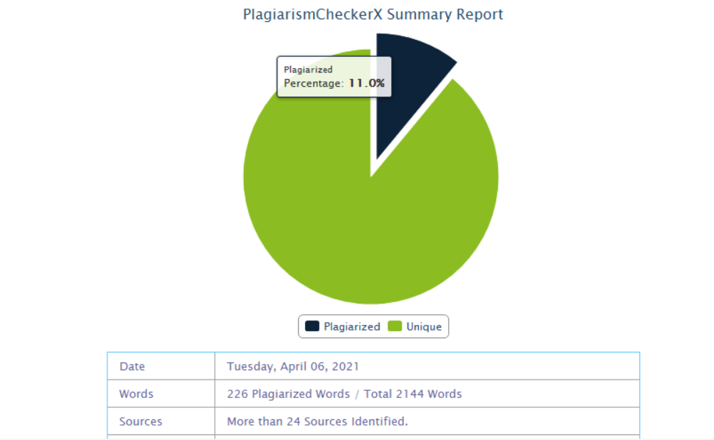

**ACKNOWLEDGEMENT**

I have a great pleasure in representing this project report entitled “**PSYCHTAXI**” and I grab this opportunity to convey my immense regards towards all the distinguished people who have their valuable contribution in the hour of need.

I like to extend my gratitude to our beloved Principal **DR. SONALI PEDNEKAR** for her timely and prestigious guidance.

I take this opportunity to thank **PROF. MRS. REENA SHAH**, Coordinator of the Department and all the professors of the Department of Computer Science of Mulund College Of Commerce, for giving me an opportunity to complete this project and the most needed guidance throughout the duration of the Program.

I am extremely grateful to my project guide **PROF. MS. PRATIKSHA HARWALKAR** her valuable guidance and necessary support during each phase of the project. She was the source of continuous encouragement as each milestone was crossed.

A special thanks to the University of Mumbai for having prescribed this project work to me as a part of the academic requirement in the Final year of Bachelor of Science in Computer Science.

Finally, I also owe to my fellow friends who have been a constant source of help to solve the problems that cropped up during the project development process.

**INDEX**

|  |  |  |
| --- | --- | --- |
| **Sr. No.** | **Topic** | **Page No.** |
| 1. | TITLE | 1 |
| 2. | INTRODUCTION | 2 |
| 3. | REQUIREMENT SPECIFICATION | 3 |
| 4. | SYSTEM DESIGN DETAILS | 4 |
| 5. | SYSTEM IMPLEMENTATION | 13 |
| 6. | RESULTS | 32 |
| 7. | CONCLUSION AND FUTURE SCOPE | 38 |
| 8. | REFERENCES | 38 |

1. **TITLE**

Title of the Project: PsychTaxi.

Type of Project: Game Application.

Developed by: Sahil Sahu.

1. **Introduction:**

For over a decade or more the gaming industry has been ruling the entertainment sector for kids and the teenagers. The graphic intensity, the gaming modes, the different genres of games that are available in the market these days from online sources like Steam, etc to your nearest offline shops, games have always kept their customers visit time and again for something more.

Amidst the gaming community and the history of gaming, making games more graphically intensive and providing it with as many features as one can has always been the key to a better hold amongst the sales and keeping the fans engaged.

This game application i.e., PsychTaxi is an application that somehow focuses on similar aspects. The poppy visuals running in the background, in the sky pair really good if the users are playing the game w their favorite music and always keeping up with the high score and being on top of the table will engage them to the screens gathering their undivided attention and focus.

* 1. **Features:**

1. Poppy Visuals.
2. 3D Graphics.
3. Easy to Play.
4. Easy to Access.
5. Live Experience.

**2.2 Advantages:**

1) Entertainment

2) Reduces excess stress

3) Improves response time

4) Improves concentration

5) Offline capability

1. **Requirement Specifications:**
   1. **Software Requirement:**

Android Version 4.0 or Higher.

Frontend : Unity, C#

Backend : PHP, MySQL

* 1. **Hardware Requirement:**

i3Processor, 4gb Ram,64-bit Operating system.

* 1. **Data Requirement:**

Integer, String, Boolean.

* 1. **Fact finding Questions:**

1. What is current application about?
2. What are the difficulties you are finding with the current application?
3. How is the data maintained?
4. May add new levels?
5. What all things do you want to add in your application?
6. Will you be able to provide an update to the application?
7. **System Design Details:**
   1. **Event Table:**

|  |  |  |  |  |  |
| --- | --- | --- | --- | --- | --- |
| Event | Trigger | Source | Activity | Response | Destination |
| User wants to play | New game | User | Click on play button | New game | Game |
| User wants to check score | Check score | User | Check on score button | Display score | Server |
| User wants to exit | Exit game | User | Click on exit button | Exit game | Home screen |

**Table 4.1 Event Table for PsychTaxi**

* 1. **Class Diagram:**

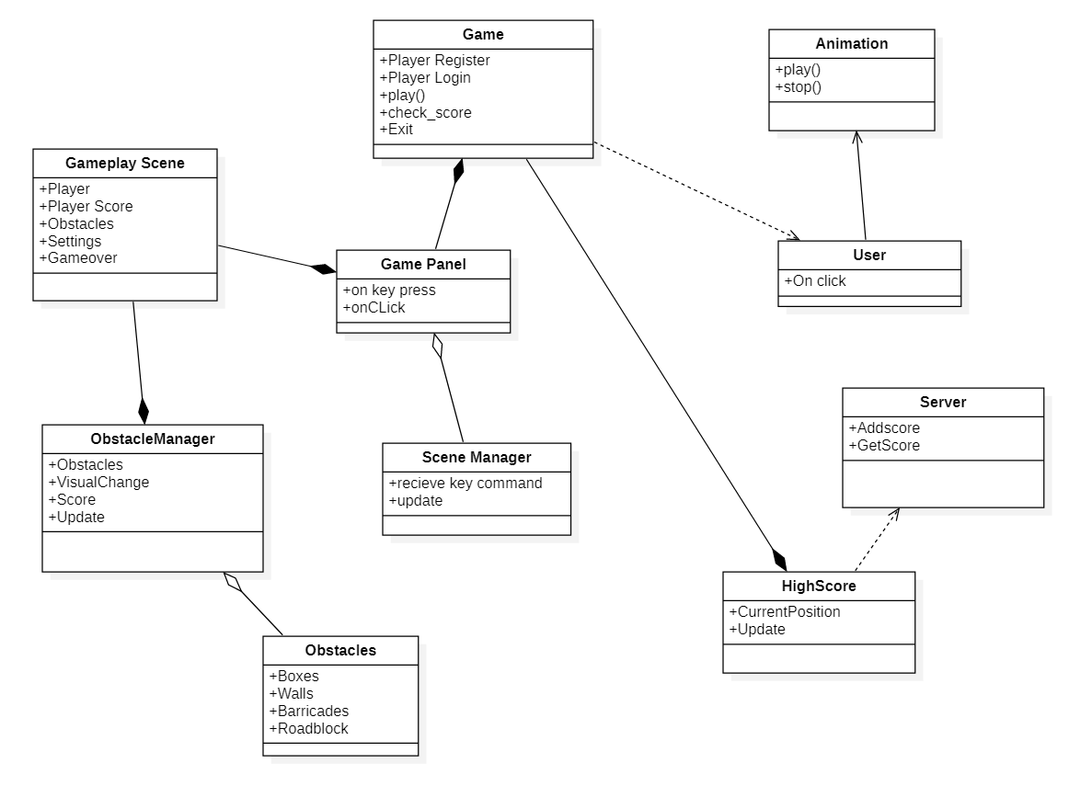

**Fig 4.2 Class Diagram for PsychTaxi**

* 1. **Use case Diagram:**

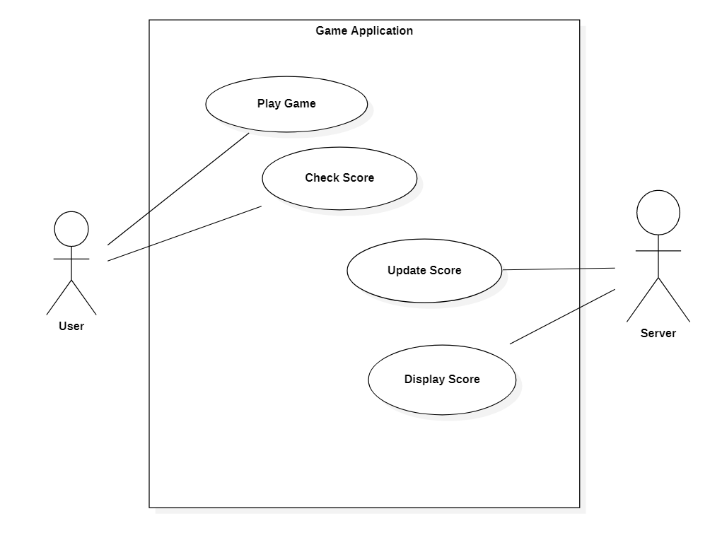

**Fig 4.3 Use case Diagram for PsychTaxi**

* 1. **Sequence Diagram:**

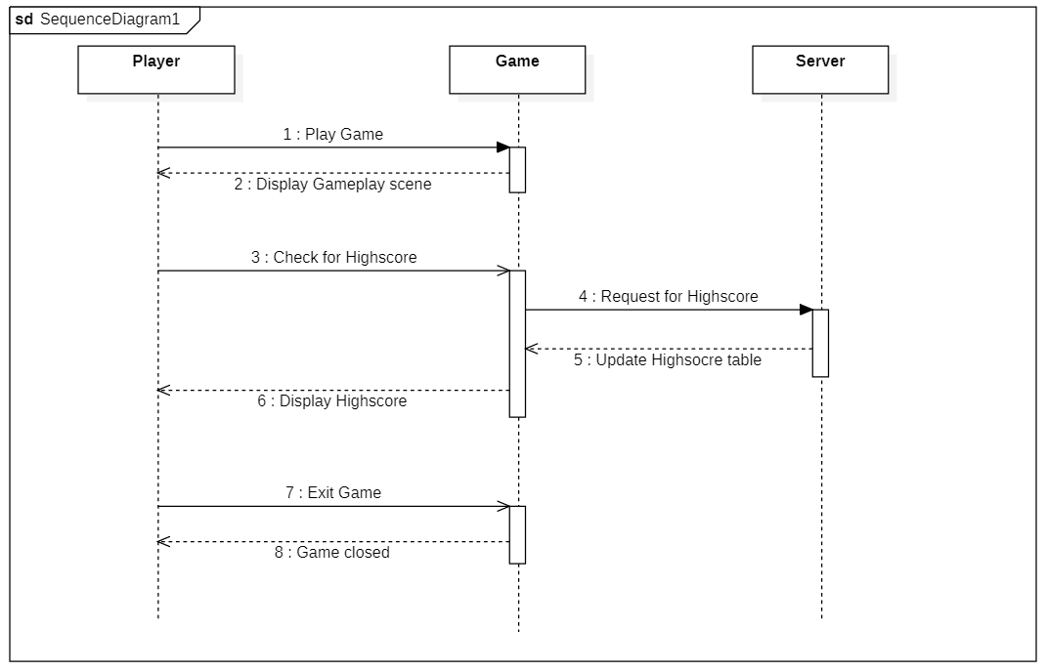

**Fig 4.4 Sequence Diagram for PsychTaxi**

* 1. **Activity Diagram:**

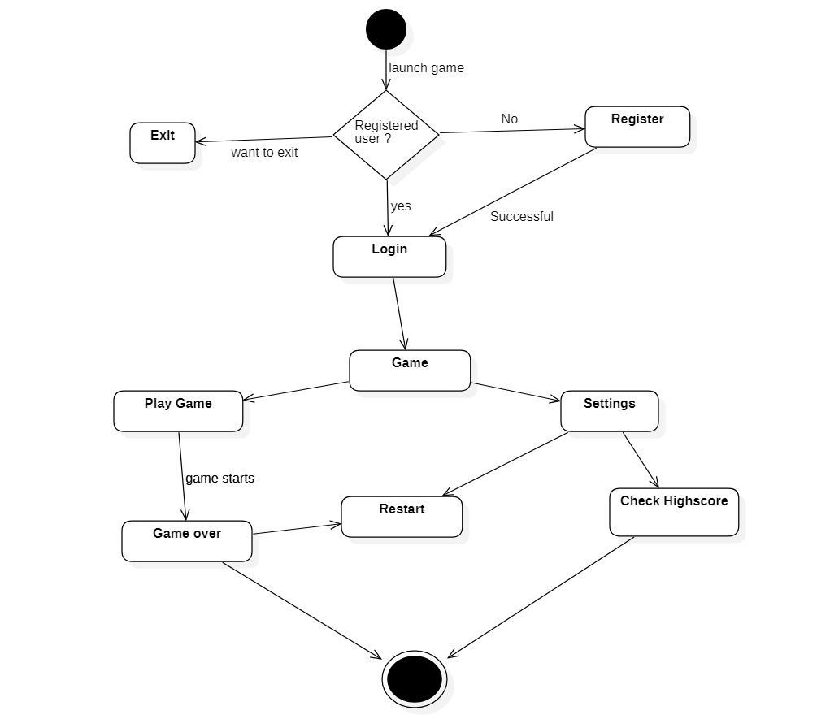

**Fig 4.5 Acitivity Diagram for PsychTaxi**

* 1. **State Diagram:**

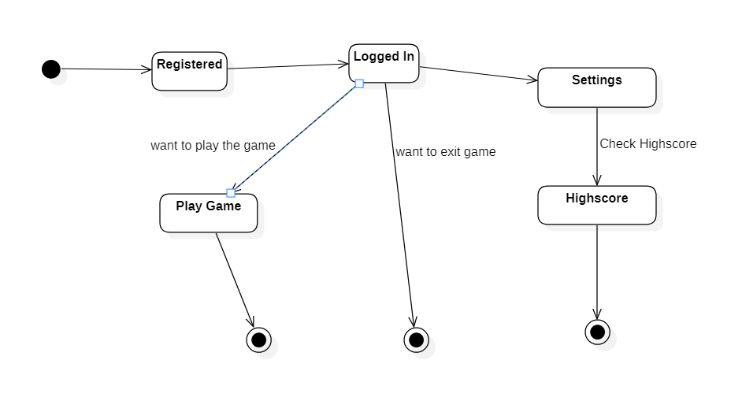

**Fig 4.6 State Diagram for PsychTaxi**

* 1. **Package Diagram:**

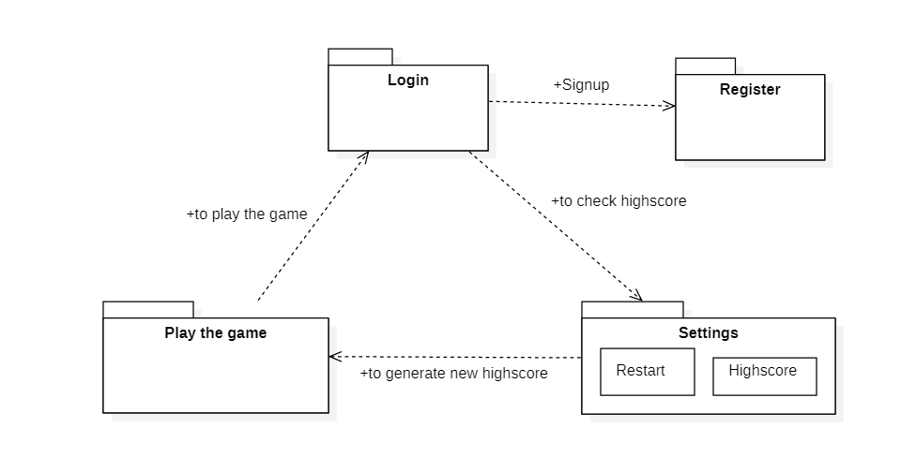

**Fig 4.7 Package Diagram for PsychTaxi**

* 1. **Component Diagram:**

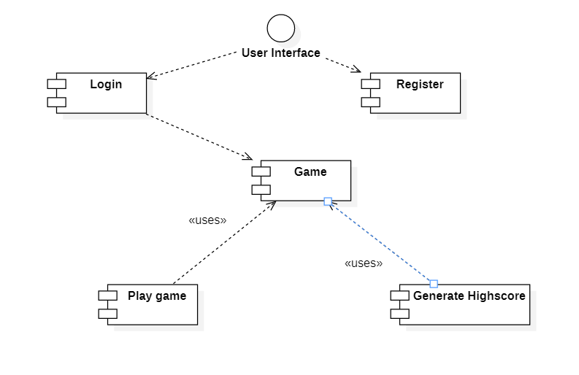

**Fig 4.8 Component Diagram for PsychTaxi**

* 1. **Deployment Diagram:**

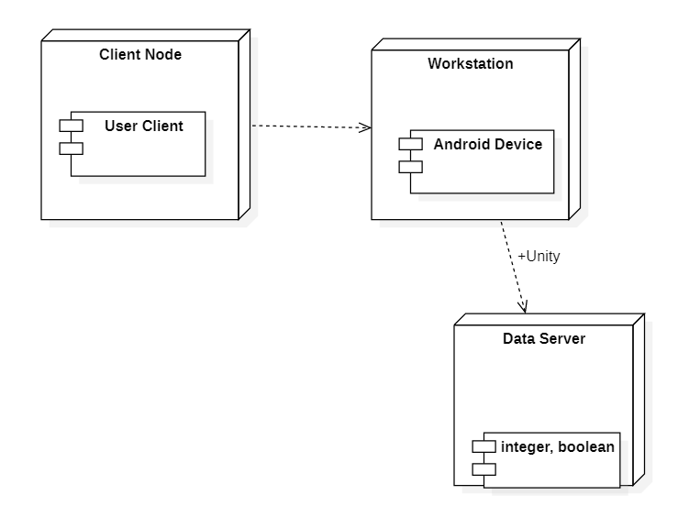

**Fig 4.9 Deployment Diagram for PsychTaxi**

* 1. **Database Design:**

|  |  |  |  |
| --- | --- | --- | --- |
| Field Name | Data type | Description | Attributes |
| Name | Varchar | Stores name of the user | Field size = max |
| Score | integer | Stores score for the user | Allow null  Field size=max |

**Table 4.10 Database Design for PsychTaxi**

1. **SYSTEM IMPLEMENTATION:**

**Code for Storing Score :**

using UnityEngine;

using UnityEngine.UI;

public class score : MonoBehaviour

{

public Transform player;

public Text Highscore;

// Update is called once per frame

void Update()

{

Highscore.text = player.position.z.ToString("0");

}

}

**Code for Player Collision :**

using UnityEngine;

public class playercollision : MonoBehaviour

{

public movement playermove;

void OnCollisionEnter(Collision collisioninfo)

{

if(collisioninfo.collider.tag == "obstacle")

{

playermove.enabled = false;

FindObjectOfType<GameManager>().EndGame();

}

}

}

**Code for Player Camera:**

using UnityEngine;

public class playercam : MonoBehaviour

{

public Transform player;

public Vector3 offset;

// Update is called once per frame

void Update()

{

transform.position = player.position + offset;

}

}

**Code for Next Level :**

using UnityEngine;

using UnityEngine.SceneManagement ;

public class nextlevel : MonoBehaviour

{

public void LoadNextLevel()

{

SceneManager.LoadScene(SceneManager.GetActiveScene().buildIndex + 1);

}

}

**Code for Quitting the game:**

using UnityEngine;

public class EndTrigger : MonoBehaviour

{

public GameManager gameManager;

void OnTriggerEnter()

{

gameManager.CompleteLevel();

}

}

**Code for Database Connection:**

<?php

$server = "localhost";

$user = "root";

$password = "";

$db = "psychtaxi";

$conn = mysqli_connect($server, $user, $password, $db);

if($conn)

{

?>

<script>

alert("Connection Successful");

</script>

<?php

}else

{

?>

<script>

alert("Connection Successful");

</script>

<?php

}

?>

**Code for User Registration :**

<?php

session_start();

include 'dbcon.php';

if(isset($_POST['register'])){

$username = mysqli_real_escape_string($conn,$_POST['user_name']);

$userpassword = mysqli_real_escape_string($conn,$_POST['user_password']);

$usercpassword = mysqli_real_escape_string($conn,$_POST['user_cpassword']);

$useremail = mysqli_real_escape_string($conn,$_POST['user_email']);

$score = mysqli_real_escape_string($conn,$_POST['user_score']);

$pass = password_hash($userpassword, PASSWORD_BCRYPT);

$cpass = password_hash($usercpassword, PASSWORD_BCRYPT);

$emailquery = " SELECT * FROM register_user where email='$useremail'";

$res = mysqli_query($conn, $emailquery);

$emailcount = @mysqli_num_rows($res);

if($emailcount>0){

echo "Email Already Exists";

}else

{

if($userpassword === $usercpassword)

{

$insertquery = "INSERT INTO register_user(user_name, user_email, user_password, user_cpassword, user_score)

VALUES ('$username','$useremail','$pass','$cpass', '$score')";

$iquery = mysqli_query($conn, $insertquery);

if($iquery)

{

echo "Inserted Successfully, Please Login now.";

}else{

echo "Insertion Unsuccessful";

}

}else

{

echo "Passwords don't match";

}

}

}

?>

<!DOCTYPE html>

<html>

<head>

<title>PsychTaxi - Leaderboard</title>

<link rel="stylesheet" href="style.css">

<?php include 'links/link.php' ?>

</head>

<body>

<div class="fresh">

<div class="sign-up-form">

<form action="<?php echo htmlentities($_SERVER['PHP_SELF']); ?>" method= "POST">

<input type="text" name="user_name" class="input-box" placeholder="Enter Username" required>

<br>

<input type="password" name="user_password" class="input-box" placeholder="Enter Password" required>

<br>

<input type="password" name="user_cpassword" class="input-box" placeholder="Confirm above Password" required>

<br>

<input type="email" name="user_email" class="input-box" placeholder="Enter Email ID" required>

<br>

<input type="score" name="user_score" class="input-box" placeholder="Enter Score" required>

<br>

<input type="checkbox"><span>I Agree to the Terms and Conditions.</span>

<br>

<button type="submit" name="register" class="signup-btn">Sign in</button>

<br>

<p>Already have an account ? <a href="login.php">Log In</a></p>

</form>

</div>

</div>

</body>

</html>

**Code for User Login :**

<?php

session_start();

?>

<html>

<head>

<title>PsychTaxi - Leaderboard</title>

<link rel="stylesheet" href="style.css">

<?php include 'links/link.php' ?>

</head>

<body>

<?php

include 'dbcon.php';

if(isset($_POST['login'])){

$email = $_POST['user_email'];

$password = $_POST['user_password'];

$email_search = "select * from register_user where user_email='$email' ";

$query = mysqli_query($conn, $email_search);

$email_count = mysqli_num_rows($query);

if($email_count){

$email_pass = mysqli_fetch_assoc($query);

$db_pass = $email_pass['user_password'];

$_SESSION['username'] = $email_pass['user_name'];

$pass_decode = password_verify($password, $db_pass);

if($pass_decode){

echo "Login Successful";

?>

<script>

location.replace("leaderboard.php");

</script>

<?php

}else{

echo "Password Incorrect";

}

}else{

echo "Invalid Email";

}

}

?>

<div class="fresh">

<div class="sign-up-form">

<form action="<?php echo htmlentities($_SERVER['PHP_SELF']); ?>" method= "POST">

<input type="email" name="user_email" class="input-box" placeholder="Enter Email ID" required>

<br>

<input type="password" name="user_password" class="input-box" placeholder="Enter Password" required>

<br>

<input type="checkbox"><span>I Agree to the Terms and Conditions.</span>

<br>

<button type="submit" name="login" class="signup-btn">Log in</button>

<br>

<p>Don't have an account ? <a href="index.php">Register!</a></p>

</form>

</div>

</div>

</body>

</html>

**Code for Leaderboard Display :**

<!DOCTYPE html>

<html>

<head>

<title>Leaderboard</title>

<?php include 'links/link.php' ?>

</head>

<body>

<div class="container">

<div class="col-lg-12">

<br><br>

<h1 class="text-warning text-center" > Database </h1>

<br>

<table id="tabledata" class=" table table-striped table-hover table-bordered">

<tr class="bg-dark text-white text-center">

<th> Id </th>

<th> Username </th>

<th> Email </th>

<th> Score </th>

<th> Delete </th>

<th> Update </th>

</tr >

<?php

include 'dbcon.php';

$q = "SELECT * from register_user";

$query = mysqli_query($conn, $q);

while($res = mysqli_fetch_array($query)){

?>

<tr>

<td> <?php echo $res['id']; ?></td>

<td> <?php echo $res['user_name']; ?> </td>

<td> <?php echo $res['user_email']; ?> </td>

<td> <?php echo $res['user_score']; ?> </td>

<td> <button class="btn-danger btn"> <a href="delete.php?id=<?php echo $res['id']; ?>" class = "text-white"> Delete </a> </button></td>

<td> <button class="btn-danger btn"> <a href="update.php?id=<?php echo $res['id']; ?>" class = "text-white"> Update </a> </button></td>

</tr>

<?php

}

?>

</table>

</div>

</div>

</body>

</html>

**Code for Updating User Data & Score in Leaderboard :**

<!DOCTYPE html>

<html>

<head>

<title>Update information</title>

<link rel="stylesheet" href="style.css">

<?php include 'links/link.php' ?>

</head>

<body>

<div class="fresh">

<div class="sign-up-form">

<form method= "POST">

<input type="text" name="user_name" class="input-box" placeholder="Enter New Username" required>

<br>

<input type="email" name="user_email" class="input-box" placeholder="Enter New Email ID" required>

<br>

<input type="score" name="user_score" class="input-box" placeholder="Enter New Score" required>

<br>

<input type="checkbox"><span>I Agree to the Terms and Conditions.</span>

<br>

<button type="submit" name="update" class="signup-btn">Update Now</button>

<br>

</form>

</div>

</div>

<?php

include 'dbcon.php';

if(isset($_POST['update'])){

$id = $_GET['id'];

$username = $_POST['user_name'];

$useremail = $_POST['user_email'];

$score = $_POST['user_score'];

$q = "UPDATE register_user SET id = '$id', user_name = '$username', user_email = '$useremail', user_score = '$score' WHERE id = '$id' ";

$query = mysqli_query($conn, $q);

if($query){

echo '<script type = "text/javascript"> alert("Update Successful") </script>';

header('location: leaderboard.php');

}else{

echo '<script type = "text/javascript"> alert("Update Failed") </script>';

}

}

?>

</body>

</html>

Code for Deleting User Data from Leaderboard:

<?php

include 'dbcon.php';

$id = $_GET['id'];

$q = "DELETE from register_user where id = $id";

mysqli_query($conn,$q);

header('location: leaderboard.php');

?>

**Code for CSS file of the Leaderboard:**

*{

margin: 0;

padding: 0;

font-family: sans-serif;

}

.fresh{

height: 100%;

width: 100%;

background-image: linear-gradient(rgba(0,0,0,0.4),rgba(0,0,0,0.4)),url(taxi.jpg);

background-size: cover;

background-position: center;

position: absolute;

}

.sign-up-form{

width: 300px;

padding: 20px;

margin: 8% auto 0;

text-align: center;

background: transparent;

box-shadow: 0 0 3px 0 rgba(0,0,0,0.3);

color: papayawhip;

}

.sign-up-form h1

{

color:palegoldenrod;

margin-bottom: 10px;

font-size: 23px;

}

.input-box{

border-radius: 20px;

padding: 10px;

margin: 10px 0;

width: 90%;

border-top: 0;

border-left: 0;

border-right: 0;

border-bottom: 1px solid #999;

outline:none;

background: transparent;

color: white;

}

button

{

background: linear-gradient(to right, #ff105f,#ffad06);

width: 90%;

padding: 10px;

border-radius: 20px;

font-size: 15px;

margin: 10px 0;

border: none;

outline: none;

cursor: pointer;

}

img

{

width: 70px;

margin-top: -50px;

}

1. **RESULTS:**

**6.1.1 Naming Conventions**

|  |  |  |  |
| --- | --- | --- | --- |
| **No** | **Name** | **Type** | **Description** |
| **1** | Button | Play button | To start the game |
| **2** | Textview | Score | To display score |
| **3** | Textview | Game Over | To display game over |
| **4** | Button | Settings button | To display settings |
| **5** | Button | Restart | To restart the game |
| **6** | Button | Highscore | To check the Highscore |

**Table 6.1.1 Table for Naming Conventions**

**6.1.2 Layouts :**

|  |  |  |
| --- | --- | --- |
| **No.** | Name | Description |
| **1** | Homescreen | Displays the home screen of application |
| **2** | Settings | Displays the Restart & Highscore button |
| **3** | Highscore | Displays Highscore table |
| **4** | Game Over | Displays game over screen |

**Table 6.1.2 Table for Layouts**

**6.2 SCREENSHOTS:**

**6.2.1 Main Menu :**

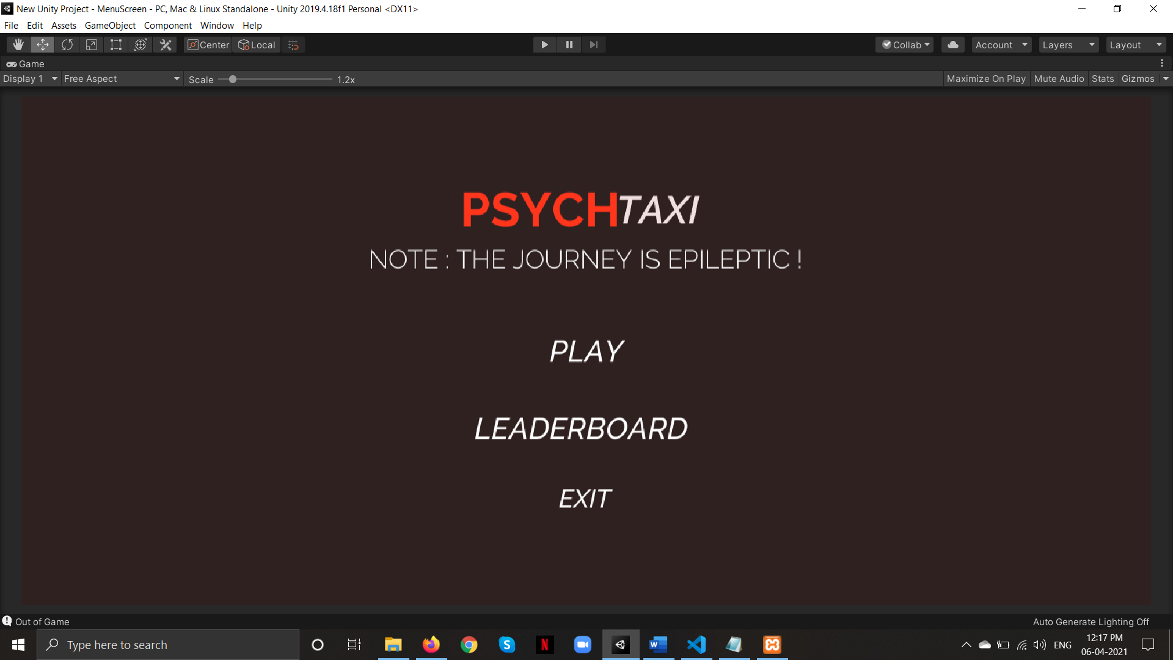

**6.2.2 Level with Score display:**

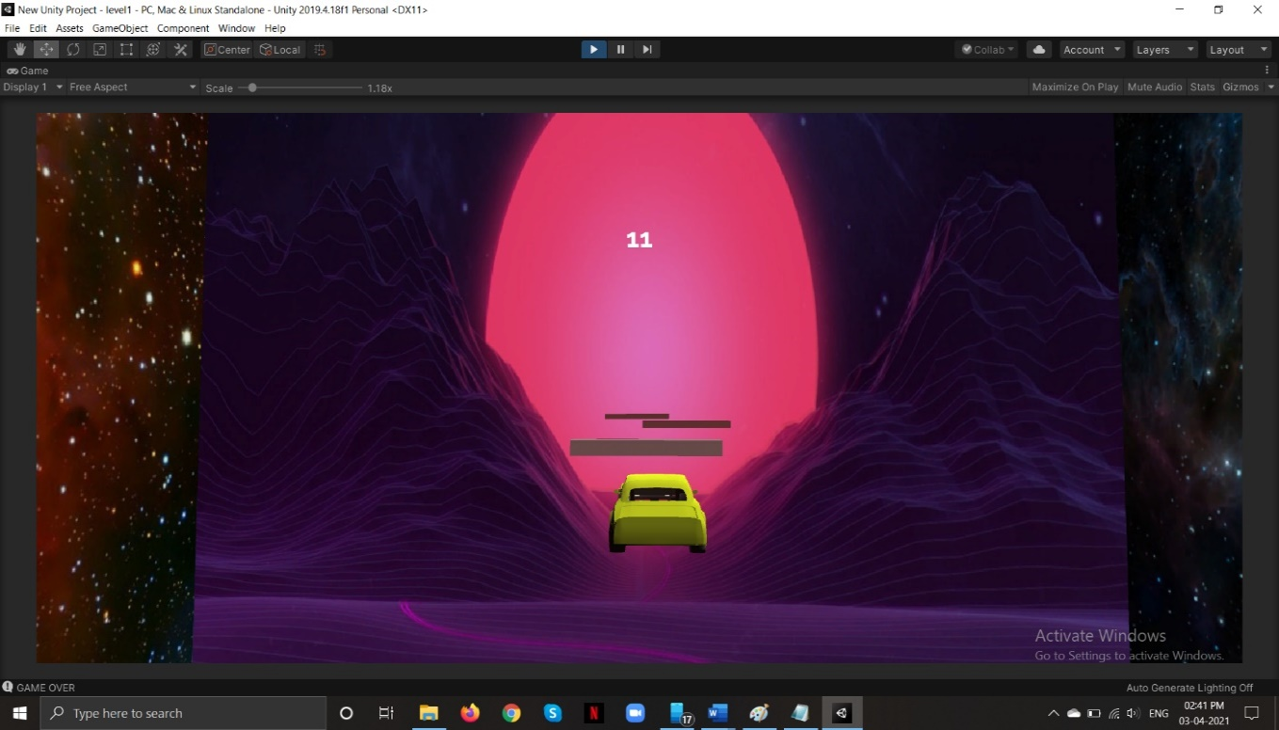

**6.2.3 Level Completion :**

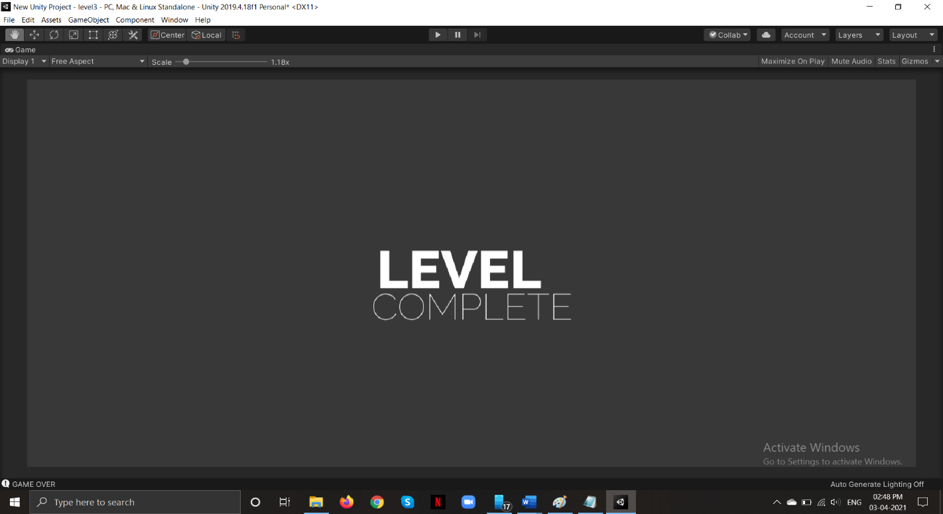

**6.2.4 Level Obstacles:**

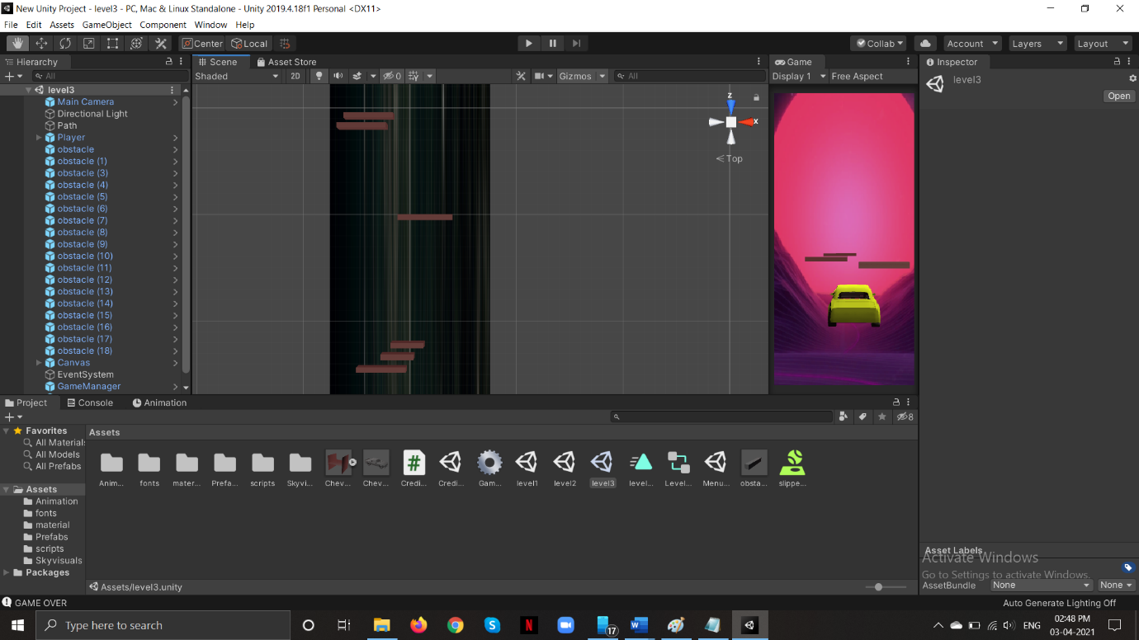

**6.2.5 Player Camera Position:**

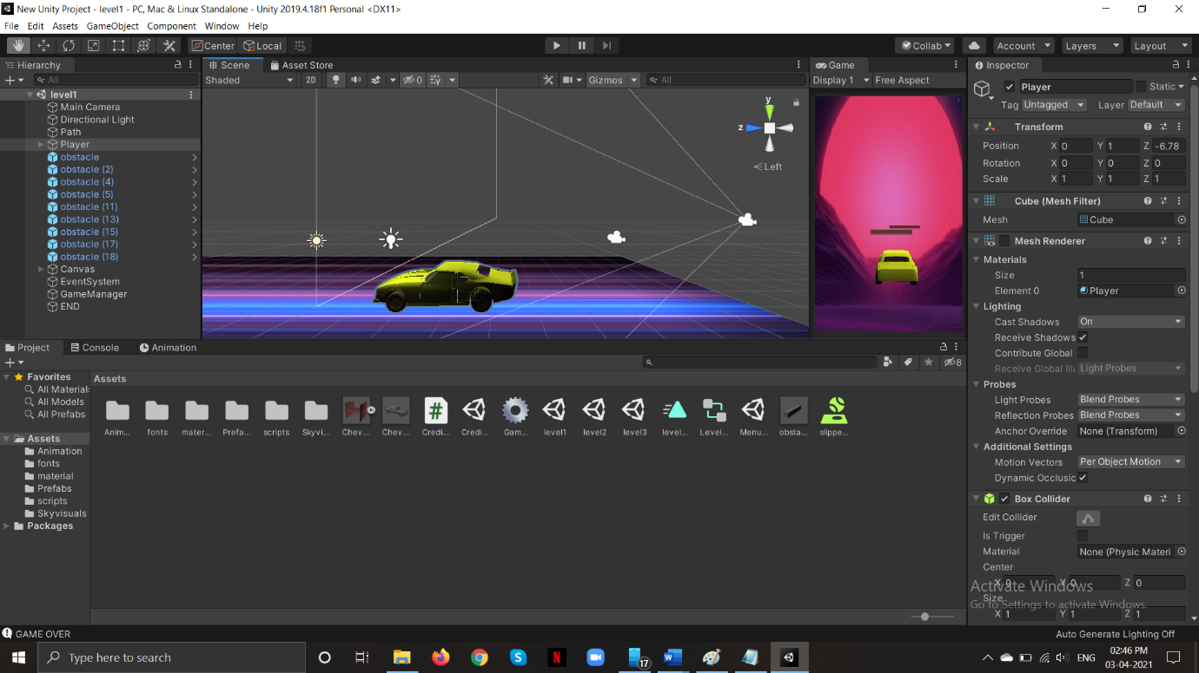

**6.2.6 Pause Menu :**

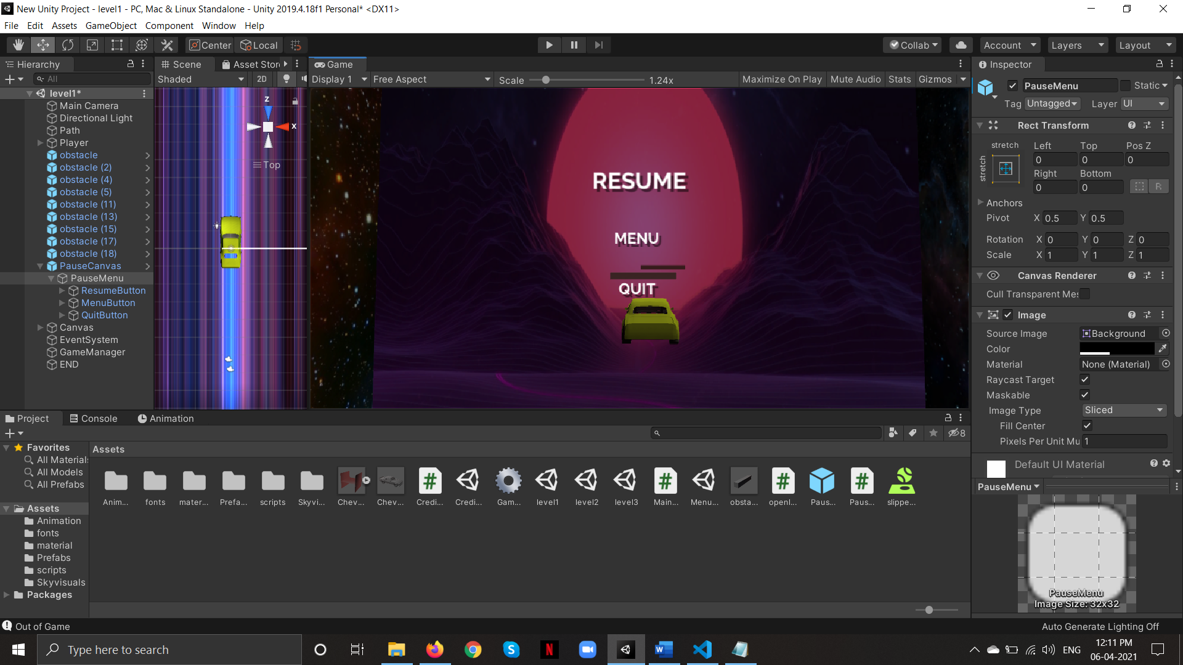

**6.2.7 Credits :**

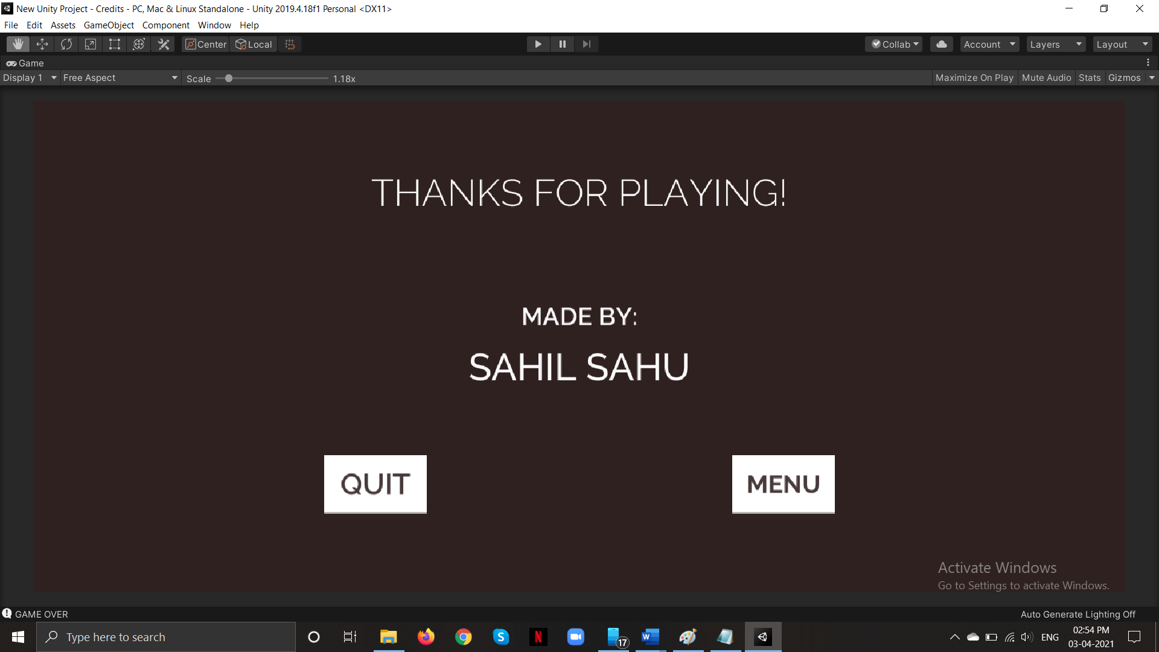

**6.2.8 User Registration Page:**

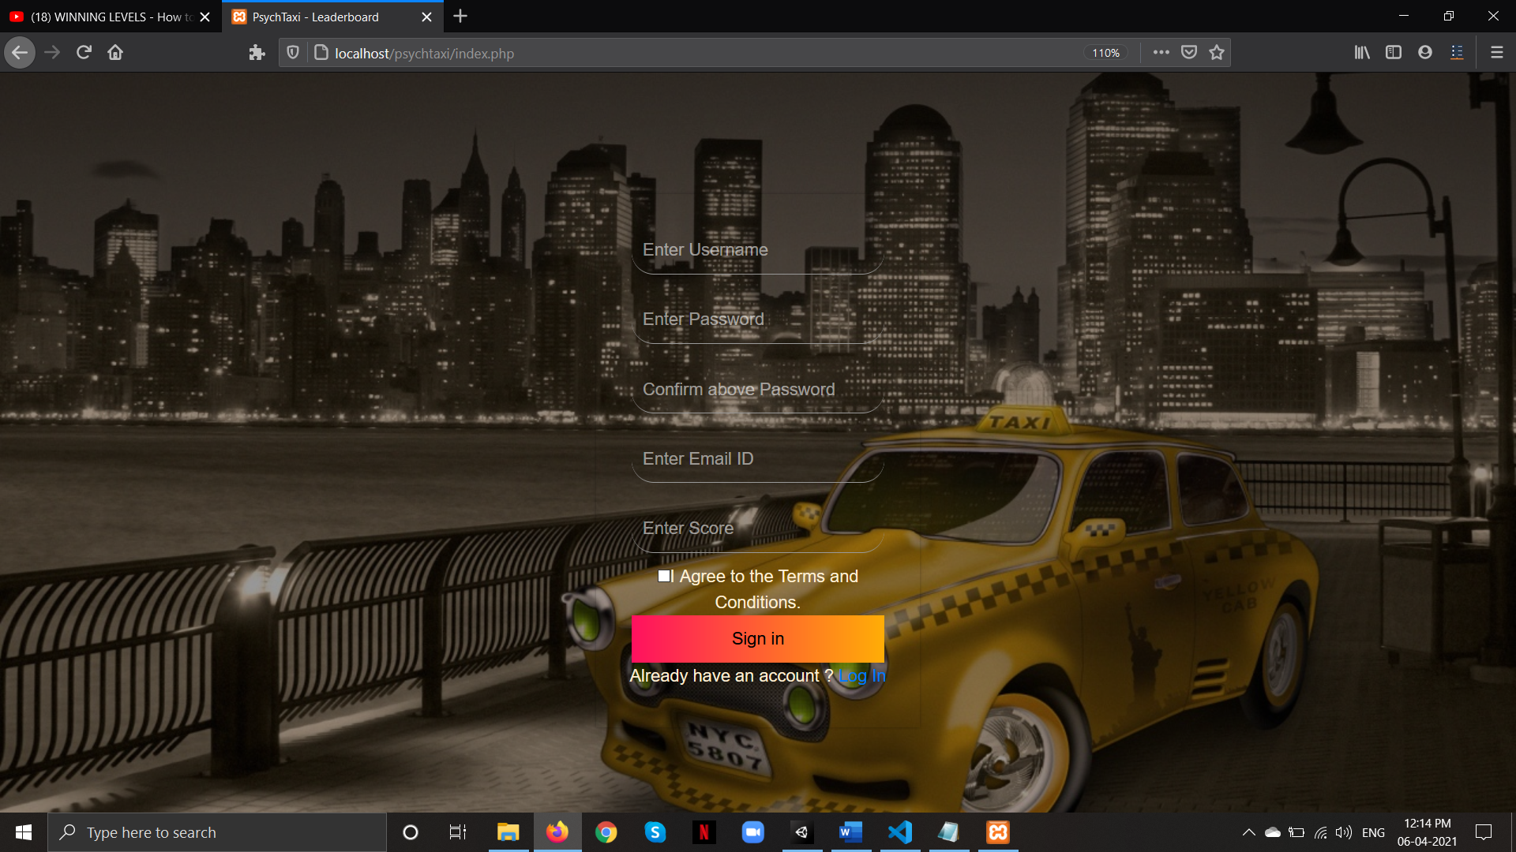

**6.2.9 User Login Page:**

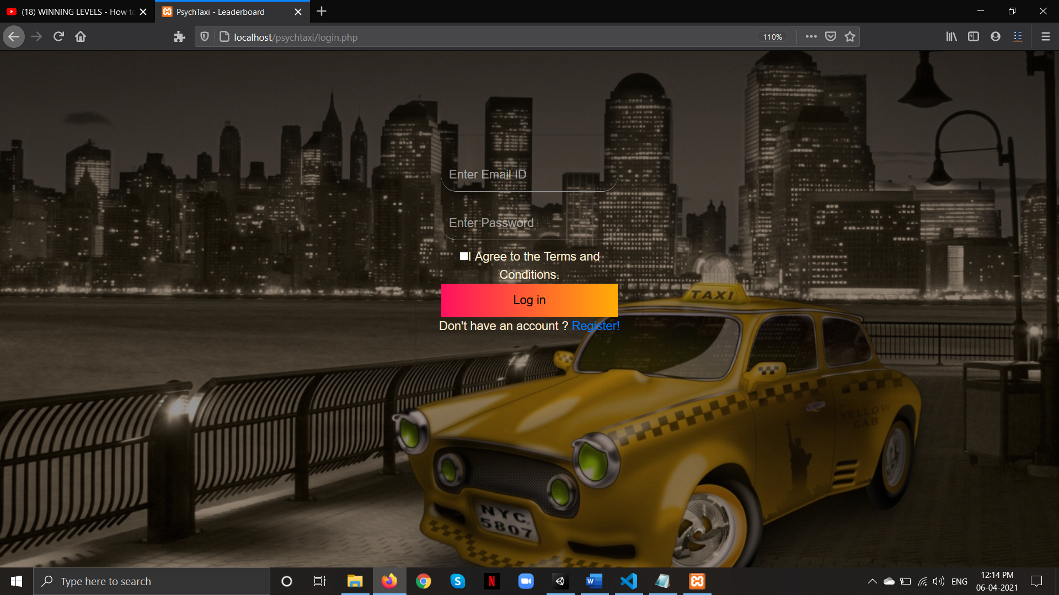

**6.3.0 Leaderboard Display Page:**

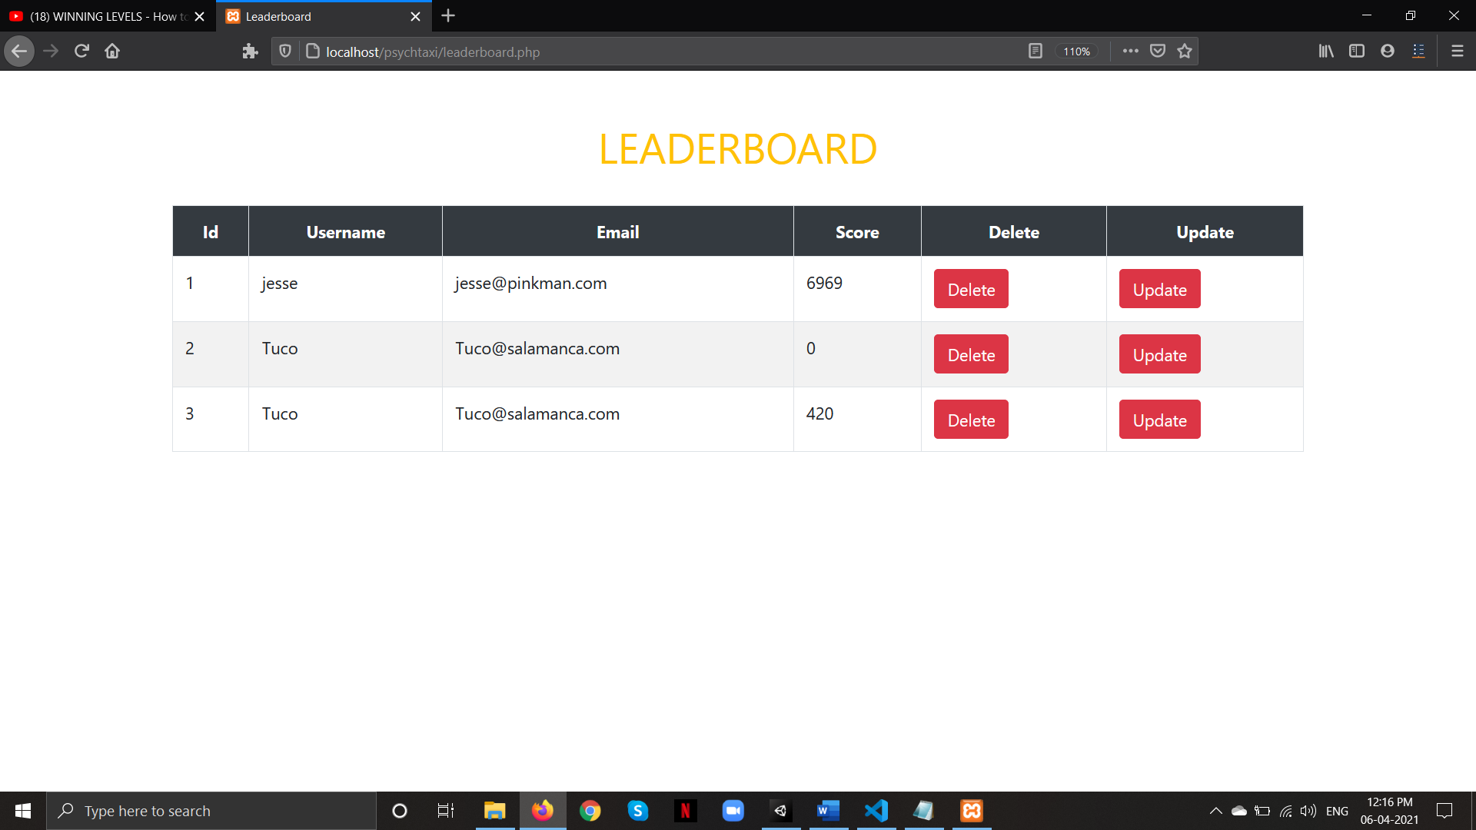

**7. Conclusion & Future scope:**

* 1. **Future Enhancement:**
* Adding a better UI to improve user experience.
* Updating the app so that it will fit for all screen size.
* Provide user with sign in from his google play account.
* Adding more levels and other interesting stuff.
* Character customization
* Better textures.

**7.2 Conclusion:**

This documentation was created with the objective of providing a systematic and logical approach to creating a 2D game. The aim of the proposed application is to provide unending entertainment to the user.

With the minimum system requirements this game can be a go to option for the users that are looking for a nostalgic gaming experience on their mobile or tablet.

One can easily play any game with user friendly environment. Its produced results in minimum time span and prevents wastage of memory. In this way game was successfully created in android. Its simple And I also think with the future updates it can turn into one of the best adventure games that are available on the android platform.

1. **References :**

* [www.youtube.com](http://www.youtube.com)
* [www.stackoverflow.com](http://www.stackoverflow.com)
* [www.w3schools.com](http://www.w3schools.com)
* [www.weblesson.com](http://www.weblesson.com)

1. **Annexures :**

**9.1 List of figures :**

|  |  |  |
| --- | --- | --- |
| **Sr.no** | **Name of figure** | **Page.no** |
| 4.2 | Class Diagram for Psychtaxi | 5 |
| 4.3 | Use case Diagram for Psychtaxi | 6 |
| 4.4 | Sequence Diagram for Psychtaxi | 7 |
| 4.5 | Activity Diagram for Psychtaxi | 8 |
| 4.6 | State Diagram for Psychtaxi | 9 |
| 4.7 | Package Diagram for Psychtaxi | 10 |
| 4.8 | Component Diagram for Psychtaxi | 11 |
| 4.9 | Deployment diagram for Psychtaxi | 12 |
| 6.2.1 | Screenshot for MainMenu | 33 |
| 6.2.2 | Screenshot for Level with Score Display | 33 |
| 6.2.3 | Screenshot for Level Complete | 34 |
| 6.2.4 | Screenshot for Level obstacles | 34 |
| 6.2.5 | Screenshot for Player Camera Position | 35 |
| 6.2.6 | Screenshot for Pause Menu | 35 |
| 6.2.7 | Screenshot for Credits | 36 |
| 6.2.8 | Screenshot for User Registration Page | 36 |
| 6.2.9 | Screenshot for Login Page | 37 |
| 6.3.0 | Screenshot for Leaderboard Display | 37 |

* 1. **List of Tables:**

|  |  |  |
| --- | --- | --- |
| **Sr.No** | **Name of Table** | **Page.no** |
| 4.1 | Event table for Psychtaxi | 4 |
| 4.10 | Database Design table for Psychtaxi | 13 |
| 6.1.1 | Naming Convention table for Psychtaxi | 32 |
| 6.1.2 | Layouts table for Psychtaxi | 32 |